THE 1ST SUFUCA WORK SEMINAR IN OULAINEN, FINLAND 10.11. – 12.11.2008

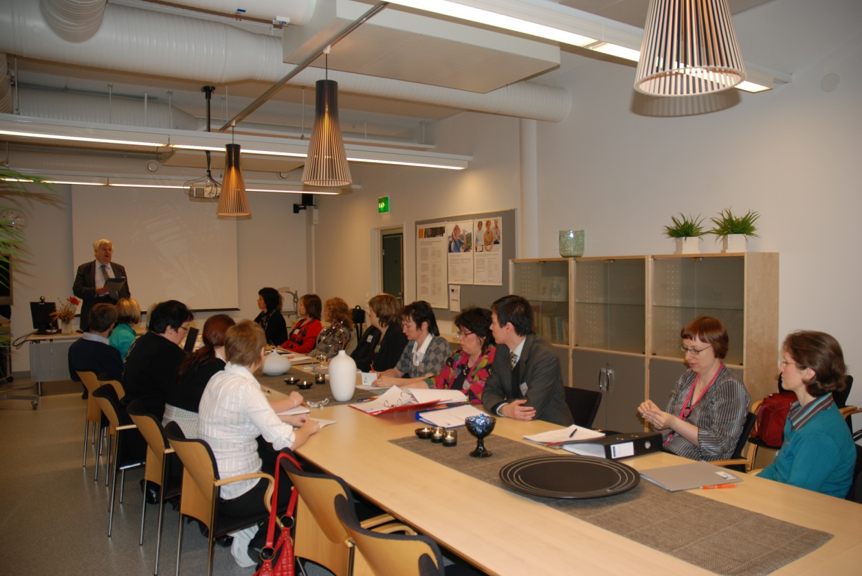
The project team got acquainted with each other and oriented to the project work.
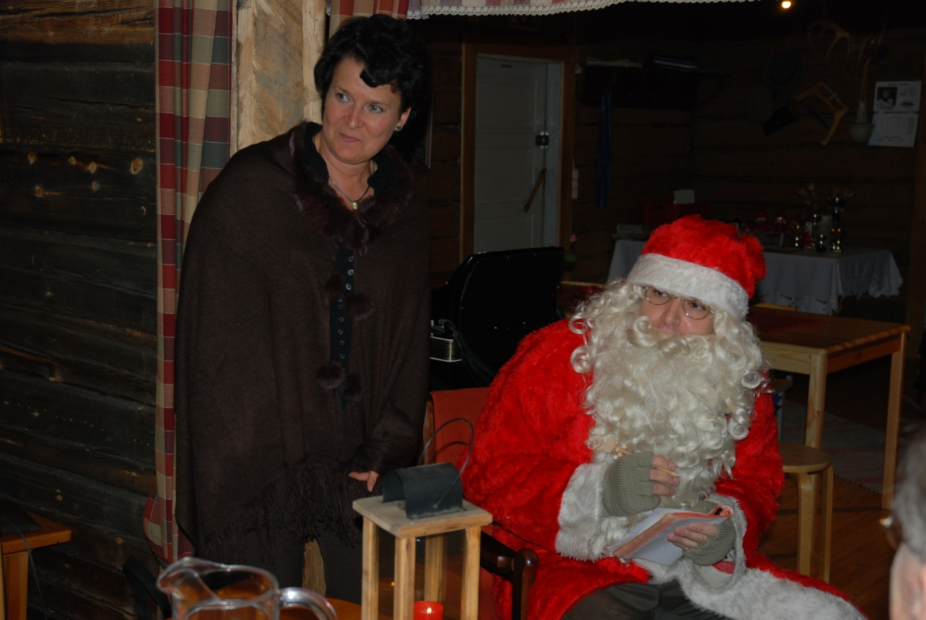
Even Santa came to meet the project team. The project manager Leena is glad to have the opportunity to help Santa to get the wishes for Christmas presents.

